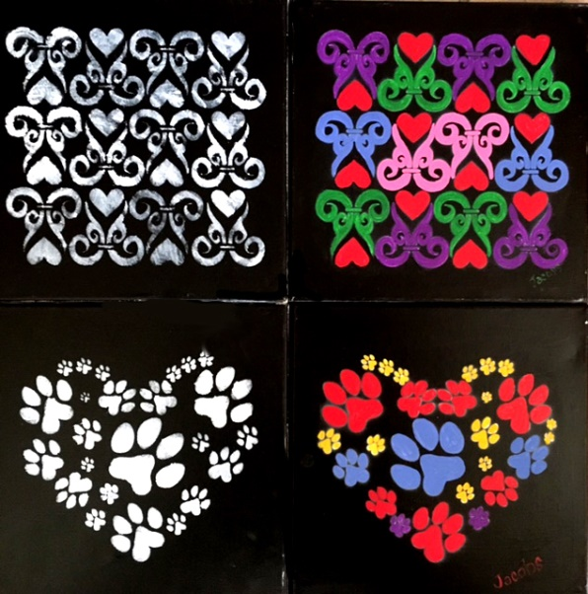


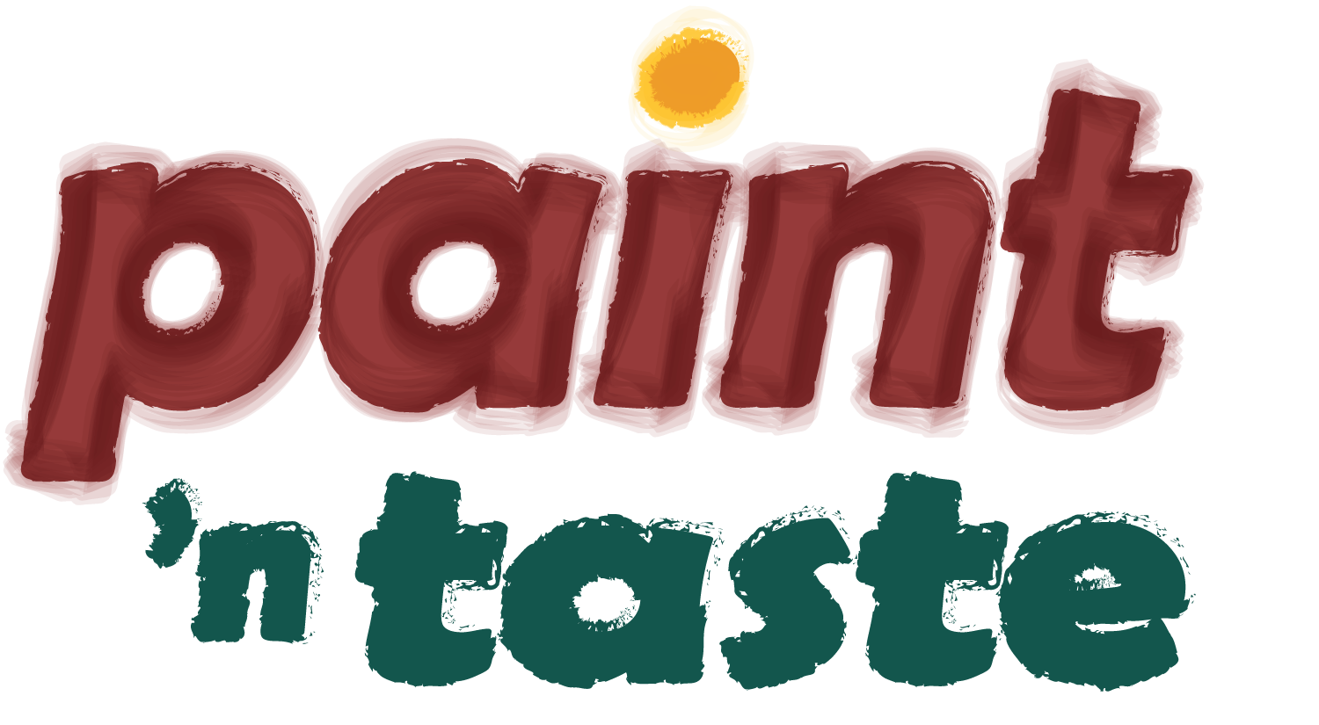
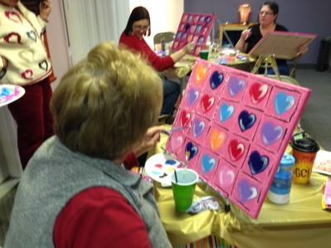
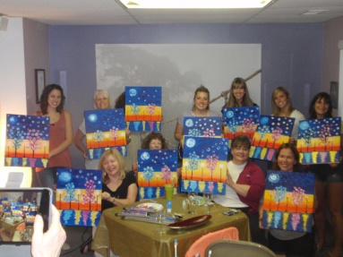

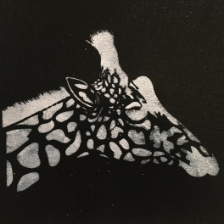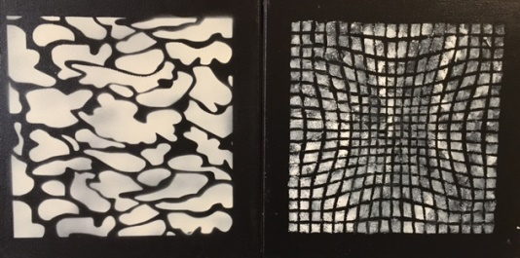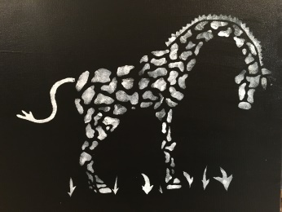
$35/person registration fee includes art supplies, light refreshments and beverages. (Please pay in advance to secure your space.)
A Moment for Me
NEW FROM Award-winning artist and local art educator, Susan Jacobs My answer to the coloring book craze! You will receive a painted black 12" canvas and a choice of stencil design. Next step is to 'pounce' your design onto the canvas with white paint over stencil, and then you can choose from an array of colors to paint any colors you wish. I will provide guidance for color scheme ideas
COLORING WITH ACRYLICS (you choose a stencil design and paint with your own color choice!)
Featuring Giraffe’s, Elephants, and Paw Prints!!!

8309 High Street NE Warren, Ohio 44483 (Howland Township)
COLORING WITH ACRYLICS!
Benefit for the Bummer Fund
Susan 330-637-3370 or Mary 330-506-0612
FRIDAY
AUGUST 19
6:30-9:30

No Experience Necessary!

